**Automation Stack in Industrial Engineering**

**Introduction**

The "Automation Stack" in industrial engineering refers to the layered architecture of technologies and systems used to automate industrial processes. This stack encompasses various components, each playing a crucial role in achieving seamless and efficient automation.

**Simplified Components of the Automation Stack**

1. **Equipment:** Physical devices and machinery used in industrial processes, such as conveyor belts and robotic arms.
2. **Programmable Logic Controllers (PLCs):** Control systems that manage a group of equipment by processing data from sensors and making real-time decisions to control devices.
3. **Supervisory Control and Data Acquisition (SCADA):** Systems that oversee and control work lines, collecting data from various control systems and providing a centralized platform for monitoring operations.
4. **Manufacturing Execution Systems (MES):** Systems that manage and monitor whole sections of production, tracking and documenting the transformation of raw materials into finished goods.
5. **Enterprise Resource Planning (ERP):** Systems that integrate and manage core business processes at the company level, such as inventory management, order processing, and human resources.
6. **Cloud Computing:** Provides scalable storage and processing power at the enterprise level, allowing for advanced analytics and remote access to data, facilitating the integration of various systems.

**Conclusion**

The automation stack in industrial engineering is a multi-layered architecture that integrates various technologies to achieve efficient and intelligent automation. Understanding each component's role and how they interact is crucial for leveraging the full potential of industrial automation.

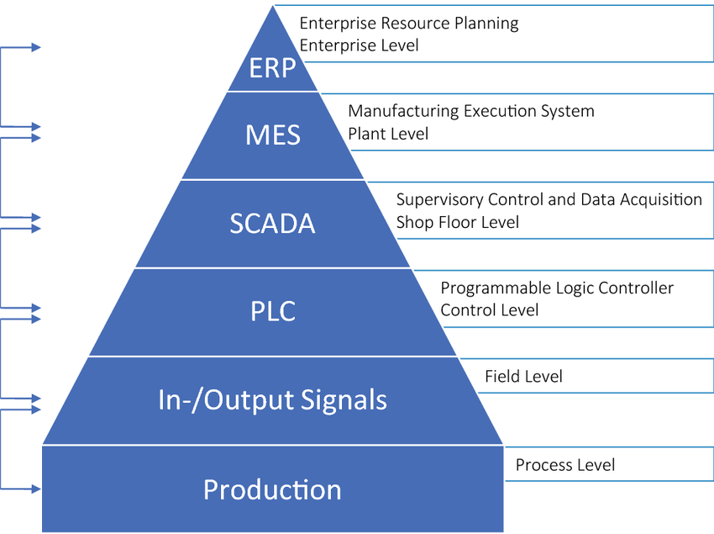

Drawing 1. Shows pyramid of automation stack